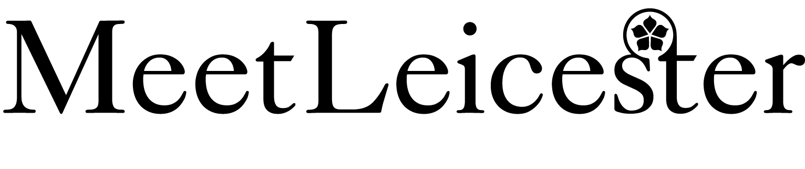

**Membership Terms**

1. **Definitions and interpretation**

The following definitions apply in these Terms and Conditions of Membership:

**Application –** Means the application form signed by the Parties agreeing to be bound by these Terms and Conditions.

**Council** – Means Leicester City Council

**Data Protection Legislation** - Means the GDPR, the LED and any applicable national implementing Laws as amended from time to time (ii) the DPA 2018 to the extent that it relates to processing of personal data and privacy; (iii) all applicable Law about the processing of personal data and privacy.

**DPA 2018** – Means the Data Protection Act 2018

**EIR** - Means the Environmental Information Regulations 2004 (SI 2004/3391) together with any guidance and/or codes of practice issued by the Information Commissioner or relevant government department in relation to such regulations.

**FOI -** Means the Freedom of Information Act 2000, and any subordinate legislation made it from time to time, and all guidance and/or codes of practice issued by the Information Commissioner or relevant government department in relation to such legislation.

**Initial Membership Period** – the initial period of Membership for the Member starting on the 1st September 2020 and ending on 31st March 2021

**Member** – Means the person/company applying for membership as stated on the Application

**Membership** – Means the membership of the Member on the Scheme

**Scheme** – Means the Meet Leicester and Leicestershire scheme operated and run by the Council

Unless the context otherwise requires words denoting the singular shall include the plural and vice versa and words denoting any one gender shall include all genders and words denoting persons shall include bodies corporate unincorporated associations and partnerships.

1. **General and Term** 
   1. By submitting the Application, the Member become a Member of the Scheme for the Initial Membership Period and agrees abide by these Terms and Conditions until the end of the initial Membership Period.
   2. The Initial Membership Period shall commence on 1st September 2020 and end on the 31st March 2021 at the end of which the Membership shall terminate.
2. **Liability**

3.1 Notwithstanding anything to the contrary contained in these Terms and Conditions, the Council’s liability whether arising from breach of contract tort including negligence breach of statutory duty or otherwise shall be limited as follows:

* + 1. In accordance with Clause 3.2 it shall be unlimited;
    2. in respect of all other liability falling outside of Clause 3.2 arising out of or in connection with its obligations under these Terms and Conditions and all actions claims demands proceedings costs and expenses arising in respect of it to £1.
  1. Neither Party limits its liability for death or personal injury caused by the negligence of itself or any of its employees or agents acting in the course of their employment or in respect of a misrepresentation made fraudulently or in respect of any breach of an implied terms in respect of title to goods.

1. **Indemnity**

4.1 The Member shall indemnify the Council, and keep it indemnified, from and against any and all losses, costs, expenses, damages, claims demands or proceedings whatsoever and howsoever to the extent arising directly (but not indirectly or consequentially) whether in contract tort including negligence under statute in common law or otherwise out of the act default negligence breach of contract breach of statute or statutory duty by the Member or any of its employees or agents acting within the course of their employment or any of its sub-Contractors and their employees or agents.

1. **Cancellation of Meet Leicester and Leicestershire**

5.1 The Council reserves the right to terminate the Scheme at any time. Should the Council terminate the Scheme the Membership shall also terminate and both parties shall be released from their obligations under these Terms and Conditions.

**6. Termination of Membership**

6.1 If at any time during the Membership the Member is in material breach of these Terms and Conditions and the breach is capable of remedy the Council may serve upon the Member a notice requiring remedy of such a breach within 14 days. Failure to remedy the breach within 14 days shall entitle the Council to terminate the Membership

6.2 If at any time during the Membership the Member is in material breach of these Terms and Conditions and the breach is in the opinion of the Council incapable of remedy the Council may terminate the Membership with immediate effect.

1. **Consequences of Termination** 
   1. On termination for whatever reason or expiry of the Membership both parties shall be released from their obligations under these Terms and Conditions.
   2. Termination or expiry of the Membership shall be without prejudice to the rights and remedies of the Member and the Council accrued before such termination or expiry and nothing in these Terms and Conditions shall prejudice the right of either Party to recover any amount outstanding as at the date of such termination or expiry of Membership.
2. **Freedom of Information** 
   1. The Member acknowledges that the Council is subject to the requirements of the FOIA and the Environmental Information Regulations and shall assist and co-operate with the Council to comply with these Information disclosure requirements.
3. **Data Protection** 
   1. Both of the Parties will comply with all applicable requirements of and all their obligations under the Data Protection Legislation which arise in connection with the Membership and these Terms and Conditions.
4. **Assignment** 
   1. The Membership is personal to the Member and shall be incapable of being assigned, sub-licenced, sub-contracted or disposed of in any way.
5. **Variation**
   1. The Council shall have the right to unilaterally vary these Terms and Conditions by providing the Member with written notice of any such variation
6. **Force Majeure**
   1. Neither party shall be in breach of these Terms and Conditions nor liable for delay in performing, or failure to perform, any of its obligations under these Terms and Conditions if such delay or failure result from events, circumstances or causes beyond its reasonable control.

## Governing Law

## The Membership and these Terms and Conditions shall be governed by and construed in accordance with the laws of England and shall be subject to the exclusive jurisdiction of the English Courts.

## Rights of Third Parties

## The provisions of the Contracts (Rights of Third Parties) Act 1999 shall not apply to the Membership and these Terms and Conditions shall not confer or be construed as conferring any right on any third party.